Ao Li – 798657

Zheping Liu – 683781

Kuan Qian – 686464

Sheng Wu – 814626

Lilian Chan – 858568

Draft Project Management Plan

myFarmXchange Case Study

Team Superstars

S1 2017

# Executive Summary

The founders of myFarmXchange plan to create a social media-style platform where farmers can connect with one another and record diary entries of their farm activities. Their vision is to invoke rural community spirit by increasing the connections within the community, and to help the farmers' economic growth in their agricultural business.

Team Superstars has been employed to help develop this system, given the budget of $50,000 and the timeframe between April to October. Considerations were given into the key functional, operational and technical requirements of the platform as extracted from the clients. An Agile Scrum method was implemented by the team, whereby tasks were allocated to members through short Sprints. The agile software development lifecycle can ensure that the project is well managed and is flexible for changes that may occur throughout the development lifecycle.

The progress of the team was measured through frequent performance reviews, creation of Burndown and Burnup charts, calculating Team Velocity and monitoring scope creep.

Contents

Executive Summary 1

1. Introduction 2

2. Project Management Plan (PMP) 3

2.1 Initiation Phase 4

2.2 Definition Phase 4

2.3 Design Phase 5

2.4 Project Management Task List 5

2.5 PMP Team Velocity 7

3. Narrative Overview 8

3.1 Groomed Product Backlog 8

3.2 Design Issues 9

3.3 Scope of Proposed Solution 10

3.4 Initial List of Stakeholders 11

4. Solution Overview 12

4.1 Sprint Backlog 12

4.2 First Sprint 12

5. Software Development Life Cycle 13

5.1 SDLC Team Velocity 13

5.2 Scope Creep 13

6. Summary 14

7. References 14

# Introduction

This document is Team Superstars' Draft Project Management Plan for the myFarmXchange Case Study project. The intended audience for this document are the team members and project supervisors. This document should be read in conjunction with the PMP and SDLC boards created on Trello and the Case Study documentation available on LMS. Revisions on this document may be made in the future.

Team Superstars has been assigned the task of creating a social network platform for farmers which could be released in time for the start of the harvest season in October. The vision for the platform is to enable farmers to form unified trading blocs, to connect users together and improve farmer community connections, and to increase prosperity in the agricultural industry from more efficient selling of crops. Ideally, the platform will also be user-friendly and extendable, making it a valuable and lasting economic investment with opportunities for future developments.

Some of the functional requirements of the platform include allowing users to register and create accounts, connect with one another, create 'diary entries', comment on them and send 'congrats'. The system will also allow users to create events and invite others to attend them. Additionally, there will be options to automatically sync account data across various devices and platforms.

Owing to the many practical uses offered by the platform, its focus on social connections and useability, it is predicted that the platform will build up loyalty within Australian farmers and rise to prominence in the market. The clients have some available funds from their Rural Infrastructure Fund grant, and there may be opportunities to earn revenue from the platform in the future.

# Project Management Plan (PMP)

The length of the project spans from the start time in April to the scheduled release date in October. From the initial vision to the final product delivery, the project will follow the typical agile project management framework as discussed by (Chandana, 2012). This includes the ‘envision’, ‘speculate’, ‘explore’, ‘adapt’ and ‘close’ phases.

Planning and management of the project is performed through use of the ‘PMP’ board, which can be accessed on Trello. This board contains the cards of the high-level, ‘epic’ project management tasks required up until the ‘explore’ phase of the project. The team plans to implement and control the project through regular, short sprints of two weeks. The length of the sprints was decided based on the de facto industry standard (Haughton, 2011), which finds the right balance between productivity, momentum and measurability. The team will meet on a weekly basis, either formally with recorded minutes, or informally as a catch-up session. The frequency of these meetings will ensure that procrastination is minimised and progress is constantly tracked. Problems can be identified early and members are given the opportunity to raise any concerns that were encountered. Additionally, the constant meetings promote better team collaboration, communication and bonding, so that performance and efficiency is maximised. After each Sprint, activities of the previous Sprint are reviewed and upcoming tasks are assigned to each member.

Team Superstars’ PMP board is as shown in Figure 1. Items in the ‘To-Do’ lane indicate tasks which are to be done in the future. Items in the ‘Doing’ lane are tasks that are currently being undertaken by a team member who has assigned themselves as a resource of that particular task. Tasks in the ‘Reviewing’ lane are items which have been completed by the member responsible and are currently under review by the rest of the team. Tasks in the ‘Done’ lane are items that have been completed and confirmed by the whole team.

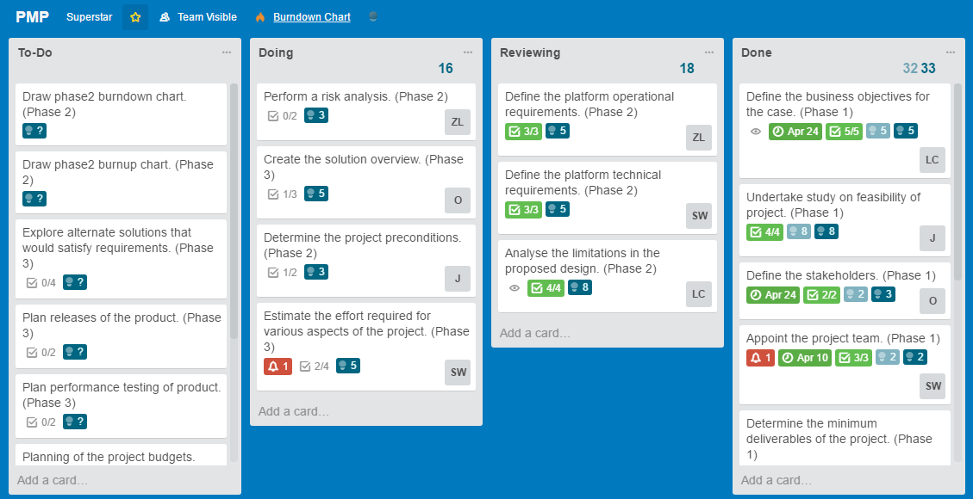

Figure : PMP board of Team Superstars created on Trello.

Tasks on the PMP board can be categorized into three phases: initiation, definition and design. Each phase corresponds roughly to a single PM sprint. These ‘epic’ user stories are listed in the PM task list below and further broken down into ‘just-in-time’ PM tasks.

The effort of each task was estimated using the story point format, which is influenced by the amount of work, complexity, risk and uncertainty involved (Cohn, 2016). The user stories are compared with one another and the values assigned are relative. Through experiences from previous projects, it was found that the use of Fibonacci numbers to represent the effort was particularly effective (Waters, 2007). This method is employed in the current example. Agreement is reached among the team regarding the effort of a particular user story that can be related to by everyone, then other user stories are ranked relatively.

For the project management task list, the story points used for the decomposed tasks were 1, 2 and 3. The story point estimate can also give some indication of required time estimates.

* 1 story point: basic, straightforward task that is easily understood and achieved
* 2 story points: task that requires some analysis and consideration
* 3 story points: task that requires extensive research and consideration of multiple factors and uncertainties

## 2.1 Initiation Phase

Initiation occurs at the beginning of the project, starting with the conceptual idea or vision from the clients (Colophon, 2017). Things to be considered include the purpose of the project, feasibility, desired results and the scope of the project. The project type is also often defined as either a research and development project, prototype delivery project or working product delivery project to ensure that the understanding between the clients and the development team are aligned.

In the myFarmXchange Case Study project, the vision of the clients is to create a farming social network that can improve farmer community connections and farmers’ economic prosperity. The project aims to deliver a final working product at the end of the development and implementation phases. Several ‘epic’ tasks were identified relating to the initiation phase, with reference to some examples of typical tasks at this stage of the project (Palmetto Document Systems, 2017). These are listed in the PM task list below.

## 2.2 Definition Phase

The definition phase occurs after the plans for the project have been approved (Colophon, 2017). During this phase, the requirements are extracted from the clients through physical or virtual meetings. They are then documented in a clearly defined manner. The expectations of all the relevant stakeholders are considered and the development team decides on the desired outcomes of the project.

Some of the different requirements that are to be considered include functional, operational and technical requirements. Functional requirements relate to the services offered by the system to the end user, operational requirements are about how to control and run the system, and technical requirements dictate how the system is to be built, considering things like language and operating systems (Project Performance Australia, 2017).

The identified PM tasks are as listed in the PM task list below.

## 2.3 Design Phase

After all of the requirements have been developed in the definition phase, the design phase can begin. Here, one or more designs that are perceived to satisfy the requirements are developed and compared (Colophon, 2017). Development may include sketches, flow charts or prototypes. The development team then decides on one of the designs and proceeds to produce a more definitive solution.

Considerations are made regarding the estimated level of effort for various tasks and the resources that are required (Azarian, 2013). Plans are made on how to implement the solution, release the product, assess performance and test the results.

Some PM tasks in this phase were identified and placed into the PM task list.

## 2.4 Project Management Task List

1. At Initiation Stage, I want to define the business objectives of the case.
   1. Arrange and attend client meeting #1 with the clients. (1 SP)
   2. Prepare questions and record survey of the clients. (2 SP)
   3. Review the case study documentation. (1 SP)
   4. Arrange and attend team meeting #1. (1SP)
   5. Create minutes for team meeting #1. (1 SP)
2. At Initiation Stage, I want to undertake a study on the project feasibility.
   1. Review documentation about existing technologies. (3 SP)
   2. Review available resources. (1 SP)
   3. Perform a preliminary cost analysis. (2 SP)
   4. Consult with relevant project supervisor. (1 SP)
3. At Initiation Stage, I want to define the relevant stakeholders.
   1. Analyse the targeted market and user base. (2 SP)
   2. Seek sponsors from perceived parties of interest. (2 SP)
4. At Initiation Stage, I want to appoint the project team.
   1. Assign the scrum master. (1 SP)
   2. Secure a project supervisor (tutor). (1 SP)
   3. Determine the strengths and experiences of team members. (1 SP)
5. At Initiation Stage, I want to define the minimum project deliverables.
   1. Arrange and attend client meeting #2 with the clients. (1 SP)
   2. Prepare questions and record a survey of the clients. (2 SP)
   3. Arrange and attend team meeting #2. (1 SP)
   4. Create minutes for team meeting #2. (1 SP)
6. At Initiation Stage, I want to define the other desired project deliverables.
   1. Review survey notes from client meeting #2. (1 SP)
   2. Perform research on the market to find business value of the extra features. (3 SP)
7. At Initiation Stage, I want to draw the Burnup Chart of Phase 1.
   1. Monitor scope creep. (1 SP)
8. At Initiation Stage, I want to draw the Burndown Chart of Phase 1.
   1. Calculate team velocity. (1 SP)
   2. Review team performance. (1 SP)
9. At Definition Stage, I want to determine any preconditions in the project. (4 SP)
   1. Analyse the functional dependencies of tasks in the project.
   2. Plan the project timeline. (2 SP)
10. At Definition Stage, I want to define the functional requirements of the system.
    1. Review surveys from client meetings. (1 SP)
    2. Produce user stories for Product Backlog. (2 SP)
    3. Produce user stories for Sprint Backlog. (2 SP)
11. At Definition Stage, I want to define the operational requirements of the system.
    1. Review surveys from client meetings. (1 SP)
    2. Produce user stories for Product Backlog. (2 SP)
    3. Produce user stories for Sprint Backlog. (2 SP)
12. At Definition Stage, I want to define the technical requirements of the system.
    1. Review surveys from client meetings. (1 SP)
    2. Produce user stories for Product Backlog. (2 SP)
    3. Produce user stories for Sprint Backlog. (2 SP)
13. At Definition Stage, I want to analyse the design limitations in the project.
    1. Determine the limitations of available technologies. (2 SP)
    2. Determine the limitations of the budget. (2 SP)
    3. Determine the limitations of other resources. (2 SP)
    4. Find the areas of improvement for current design plan. (3 SP)
14. At Definition Stage, I want to analyse the risks of the project.
    1. List the economic risks of the project. (2 SP)
    2. List the time limitation risks of the project. (2 SP)
15. At Definition Stage, I want to draw the Burnup Chart of Phase 2.
    1. Monitor scope creep. (1 SP)
16. At Definition Stage, I want to draw the Burndown Chart of Phase 2.
    1. Calculate team velocity. (1 SP)
    2. Review team performance. (1 SP)
17. At Design Stage, I want to create the Solution Overview.
    1. Arrange and attend client meeting #3 with the clients. (1 SP)
    2. Describe the proposed solution. (2 SP)
    3. Identify the boundaries between included and excluded components. (2 SP)
18. At Design Stage, I want to estimate the effort required for various aspects of the project.
    1. Arrange and attend team meeting #4. (1 SP)
    2. Create minutes for team meeting #4. (1 SP)
    3. Perform research on ‘effort’ in related past projects. (2 SP)
    4. Assign story points to user stories. (2 SP)
19. At Design Stage, I want to plan the release schedule of the platform.
    1. Arrange and attend client meeting #4 with the clients. (1 SP)
    2. Create timeline of scheduled releases and included features. (1 SP)
20. At Design Stage, I want to plan performance testing.
    1. Define performance requirements guidelines. (2 SP)
    2. Design performance tests for the system. (2 SP)
21. At Design Stage, I want to allocate the budget available for the project.
    1. Arrange and attend client meeting #5 with the clients. (1 SP)
    2. Perform research of required costs of certain components. (2 SP)
    3. Discussion and record the budget allocations. (2 SP)
22. At Design Stage, I want to explore alternative solutions for the project.
    1. Research on other available solutions for the project. (3 SP)
    2. Analyse the benefits of other solutions. (2 SP)
    3. Analyse the risks of other solutions. (2 SP)
    4. Analyse the costs of other solutions. (2 SP)
23. At Design Stage, I want to draw the Burnup Chart of Phase 3.
    1. Monitor scope creep. (1 SP)
24. At Design Stage, I want to draw the Burndown Chart of Phase 3.
    1. Calculate team velocity. (1 SP)
    2. Review team performance. (1 SP)

The complexities and effort required to complete the ‘epic’ user stories were then discussed on and agreed upon by the team. Considerations were made regarding the story points of the low-level user stories it was comprised of and ranked on the Fibonacci scale of 1, 2, 3, 5 and 8.

## 2.5 PMP Team Velocity

The story point estimates for each task card on the PMP board were used to calculate a high-level estimate of the length of each Sprint. This is displayed in the Burndown Chart in Figure 2.

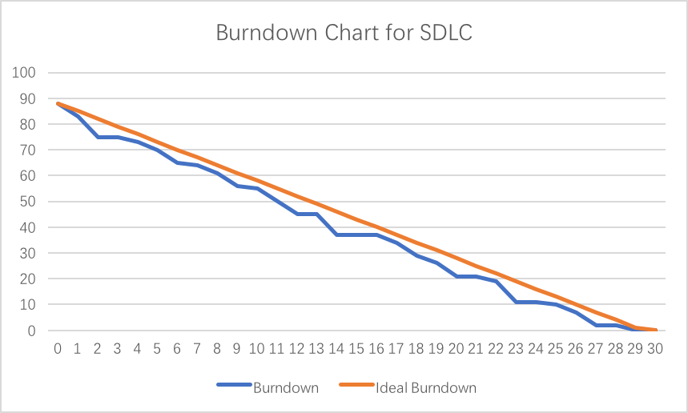

Figure : Team Superstars’ PMP Sprint velocity as represented on a Burndown Chart.

After completion of the task cards, the team discussed a more accurate measure of the actual effort required by the activity and recorded this on the cards. This was used to measure the progress of the Sprint by creating a Burnup Chart, as shown in Figure 3.

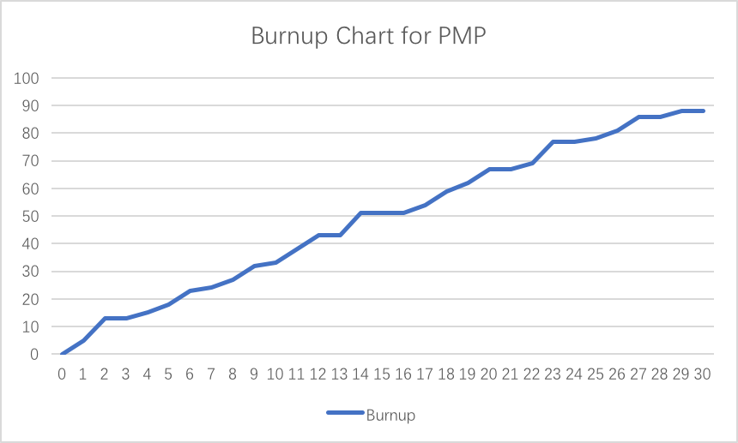

Figure : Team Superstars’ Sprint progress as represented on a Burnup Chart.

The team velocity of Team Superstars during the PM Sprints were found to be as follows:

Week 1: 18 story points/week

Week 2: 15 story points/week

Week 3: 18 story points/week

Week 4: 17 story points/week

Week 5: 20 story points/week

# Narrative Overview

The design problem currently presented to the development team is to plan, build and implement a social media platform with a farming theme. The clients aim to enable farmers to form unified trading blocs through this application, simultaneously improving farmer economic prosperity and farmer community connections. It will be a tool targeted towards farmers and other interested parties, offering services to help monitor national grain price fluctuations, analyse the market and track performance within farms. The platform will be developed with the view of possible future enhancements. The clients aim to earn revenue from the application when it becomes prominent in markets.

The key requirements that were gathered from client meetings and virtual client discussions are as documented in the Product Backlog. The order in which the items are listed is indicative of the priority of the feature.

## 3.1 Groomed Product Backlog

1) As an active user and farmer, I want to create diary entries to record farm indicators/activities, so that I can track performance/improvement. (8 SP)

2) As a user, I want to create an account and profile so that I can access the platform from various devices. (5 SP)

3) As an active user, I want to have search and connect functions between users, so that I am able to connect with other farmers sharing the same interest in crops. (3 SP)

4) As an active user, I want to send comments and ‘congrats’ to other users, so that I can build community connections and we can support one another. (3 SP)

5) As an active user, I want to create events and invite my connections to attend so that farmers can increase revenue in selling grains and share knowledge. (3 SP)

6) As an active user, I want to sync the platform with other mobile devices such as weather stations and fitness tracking, so that more data can be easily recorded. (2 SP)

7) As an active user, I want to sync the platform with other existing farm services, so that it is convenient and more users will be attracted to start using it. (2 SP)

8) As a user, I want to be able to run the platform on all versions of Windows starting from Windows 7 (Non-functional - usability). (2 SP)

9) As a user, I want to be able to run the platform on all types of browsers, including Firefox, Chrome and Safari, so that I can use the platform with any kind of browser (Non-functional - usability). (2 SP)

10) As a user, I want the platform to look similar both on web browsers and mobile devices, so that it’s easy for me to get familiar with (Non-functional - usability). (2 SP)

11) As an administrator, I want the platform to be easy to restart whenever it crashes, so that it's easier to keep persistent service (Non-functional - reliability). (2 SP)

12) As a user, I want the site to be available 99.999 percent of the time when I am attempting to access it, so that I don’t get frustrated and find another site to use (Non-functional - availability). (2 SP)

13) As an administrator, I want our platform to support different human languages, so that all global users who speak different languages can use the platform (Non-functional - performance). (2 SP)

14) As a user, I want the validation on the login page to be very clear, so that I can easily see when/if I make a mistake when I log in (Non-functional - security). (2 SP)

15) As an administrator, I want our platform to validate active users before giving them an account, so that malicious attacks on the platform can be avoided (Non-function - security). (2 SP)

16) As an administrator, I want our platform to have some load tests, so that we can be aware of the maximum load capacity of our platform (Non-functional – scalability). (2 SP)

17) As an administrator, I want our platform to have some security mechanisms, so that users’ privacy can be protected in the future when “eBay-style” transaction processing features are introduced (Non-functional – security). (2 SP)

18) As an administrator, I want the platform to automatically switch between backup databases, so that it can easily use a different database whenever problems are encountered with one (Non-functional - availability). (2 SP)

19) As an administrator, I want the platform to use multiple repeated databases rather than just one, so that we can keep availability whenever one database crashes (Non-functional - reliability). (2 SP)

20) As an administrator, I want our databases to be built in regions where there are many users, so that the platform performance speed is maximised and data is returned quickly to the majority of users (Non-functional – performance). (2 SP)

In assigning the story points, consideration was given into client priority, amount of work to be completed, complexity of the tasks and uncertainties involved. Although the estimates do not necessarily have to be accurate, they need to be consistent (CA Technologies, 2017). Inaccuracies in estimates could then be corrected from the calculated Sprint velocities.

## 3.2 Design Issues

One of the most complex issues in the current design problem is relating to implementation of the dairy entry function. There is a variety of diary entry types, such as farm activities, text-based entries, and measurements. Each of the entries also has different data fields (some can be optional), and therefore needs to be handled slightly differently during user input, storage and presentation. The system may be required to support new types of fields in the future. When such changes happen, it should not affect existing data, or require any specific user actions to take effect, otherwise it will lead to major usability issues.

Additionally, the diary entries all contain an estimate of the cost based on activity type, duration, location and markets. The estimation needs to be reasonably accurate so that it is of practical use to users when they are managing their activities. Obtaining such an algorithm for decent estimation can be difficult. If such an algorithm is heuristic or supervised, its effect may be limited in the beginning, since not much user information is available at the launch of the product.

Since the service is built for farmers and other people interested in farming activities, the targeted users generally do not have strong technical backgrounds, so the service must be easy to use. Frequently performed actions should be executed in a straightforward way with minimal procedures required. In order for this to be realised, user interface of the service needs to be carefully designed. A web interface (ie. website) needs to be implemented for maximum user coverage and instant access, while it is still desirable that mobile applications are also built for better experience on specific mobile platforms (such as Android and iOS).

Although the documentation from the case study specifies major functionality requirements, there are other implicit features that need to be employed by the platform. Some functionalities, although not specified as a minimum deliverable, are still required so that other functions can be implemented. For example, some type of interface needs to be provided for administrators, to enable them to view reports and disable users who violate the Code of Conduct, and functionality needs to be added so that all diary entries can be edited or deleted. For the data to be stored and accessed, some type of storage system, typically a database, needs to be implemented.

Design issues also exist when importing external data. As specified in the requirements, data supported by myFarmXchange needs to be automatically synced from other linked farm services. However, it is not clear what level of support the other farm services provide for reading user data. Some form of API is required for the program to automatically read new data from the services, but it is not always provided. For example, some services may only provide functionality in exporting data as a file. In this case, some actions need to be performed manually by the user each time data is imported to myFarmXchange. In the worst case scenario, no functionality is provided for exporting data from other services, making even transferring data an extremely difficult task and automatic syncing of data nearly impossible.

Similar to the previous issue, data supported by myFarmXchange needs to also be automatically synced from mobile devices that track activities and measurements and turned into diary entries. In order to do so, the system needs to be flexible enough to support different data sources. Each device may need to be accessed differently due to the different interfaces they provide and different data types. The system needs to handle each of them differently, but all types of data should be converted to one of the standard types of the dairy entry.

## Scope of Proposed Solution

Several high-level tasks were identified as part of the proposed scope of a solution to meet the basic requirements of the design problem.

Apps are to be built for major mobile operating systems such as Android and iOS, so that users can access the service with their mobile devices conveniently. In order for the user to access the service on their computers, a website needs to be built, set up, and maintained. The website can also be designed to support mobile devices in the case where the mobile app is not available to a user.

* Both the website and the mobile app are to be created on the basis of a social media site including the functions to connect users, send comments and 'congrats'. This differentiates the application from others and helps promote farmer communities connections. It should also be designed for high usability, so that the service is easily accessible for people of all backgrounds and ages, especially farmers with little to no technical knowledge. The platform should implement functions to make and attend events, further contributing to the promotion of farmer grain sales and improving economic prosperity. Additionally, farmers can share their experiences at these events, encouraging connections and facilitating sharing of expertise. Functions are to be implemented to create diary entries about farm activities, which can help farmers monitor performance and track improvements. There will also be an algorithm deriving estimated costs of farm activities from the type, duration, location and markets.
* A database is to be set up to store user information and dairy entries, so that users’ inputs into their profiles and dairy entries can persist indefinitely. The database should be deployed on a server with an interface provided for access from the mobile apps and the website. This allows users to always see the latest information on any of their devices, and to make changes that are instantly available for viewing by others. The database is to be designed to easily support future enhancements and changes, and optional fields are well supported.
* The system is to be made to support external data sources, with built-in data adapters to support common farm measurement devices and mobile farm services. This helps to save time for users from migrating their data manually and provides them with a unified place for all their farm data. Investigation needs to be made to the interfaces provided by the services/devices, for data to be imported from those sources.

## Initial List of Stakeholders

1. *The development team* is a group of 5 relatively inexperienced software engineers. The team has experience in Java programming and databases.
2. *The clients* are Wilma Flint and Barnaby Rubble, founders of myFarmXchange who are wheat farmers and technology enthusiasts.
3. *Farmers* who want to connect to other farmers within the community and share their activities.
4. *The local council* who may share the interest of improving the farming communities’ prosperity and connections. They may seek to invest in the platform.
5. *Other technology enthusiasts* who are interested in the agricultural industry and social media platforms.

# Solution Overview

Some features that were perceived to contribute to achieving the desired requirements were chosen and listed as ‘epic’, high-level user stories in the Sprint Backlog, as shown below.

## 4.1 Sprint Backlog

1. As an active user, I want to add harvest task activities into my diary, so that I can track my harvest tasks to improve performance.
2. As an active user, I want to add a selling task activity into my diary, so that I can improve my economic prosperity in selling grain.
3. As an active user, I want to add storage task activities into my diary, so that statistics about good storage reasons can be concluded from my grain storage records.
4. As an active user, I want to add a maintenance task activity into my diary, so that I can improve the quality of grain.
5. As an active user, I want to add an equipment upgrade activity into my diary, so that I can help others know the effect of the equipment upgrade.
6. As an active user, sometimes I want to upload some map data of my farm paddock in a standard GPS file format (tcx or gpx), so that I can clearly tell others about the location of my farm.
7. As an active user, I want to add entries for concrete farm measurements, so that I can measure my farm performance.
8. As an active user, I want to add date, cost estimation and unit of measure to my concrete farm measurements, so that I can display more details to other users.
9. As an active user, I want to add entries for indirect measures, so that I can foster productivity innovations.
10. As an active user, I want to add date, type of measure and cost estimation to my indirect farm measurements, so that I can display more details to other users.
11. As an active user, I want to add text-based diary entries, so that I can write comments about how I am doing against my goals.
12. As an active user, I want to attach photos and videos, so that I can share some real photos of the farm and videos of farm activities with my friends.
13. As an active user, I want to add comments about how I performed against my goals or some other piece of information, so that I can share with my friends.
14. As an active user, I want to be able to post comments on other users’ entries, so that the platform can be like other social media sites like Facebook.
15. As an active user, I want to be able to create diary entries to record farm indicators/activities, so that I can track performance/improvement of my farm.
16. As an active user, I want to be able to delete my activity entries, so that I can manage my posts.
17. As an active user, I want to edit my activity entries, so that I can update or change the information posted.
18. As an administrator, I need to ensure that entries added by active users from different devices are stored in the same database, so that there will not be mismatching entries on different platforms.
19. As an administrator, I need to maintain several different data entries that were recorded for different types of activities, so that it will improve user experience and attract more users to use it.
20. As an administrator, I want to ensure that users store a date, start time and duration in every activity, so that we can track and give some statistics about averages to users.
21. As an administrator, I want to ensure users store an estimate of the cost of the activity based on the activity type and duration, so that we can track and give some statistics about averages to users.
22. As an administrator, I want to ensure users store crop type, quantity and quality for each farm activity, so that we can track and give some statistics about averages to users.
23. As an administrator, I need to store map data of the farm paddock in a standard GPS file format, so that the map data can be shared to other users.
24. As an administrator, I want to ensure users store cost estimates, dates and units of measure for their concrete farm measurements, so that it is ensured users entered concrete measurements.
25. As an administrator, I want to ensure users store dates, types of measure and cost estimations for indirect measures, so that it is ensured users can create objective indirect measurements.
26. As an administrator, I need to manage the storage of text-based diaries of different lengths, uploaded by users, so that users can upload various lengths of text-based diary.
27. As an administrator, I need to store photos and videos that users upload, so that users can share them with others.
28. As an administrator, I need to manage the storage of different lengths of comments uploaded by users, so that users can upload various lengths of comments.
29. As a user, I want to register as either an active member or an observer, so that I can log into the platform.
30. As an active user, I want to provide my official National Growers Registration (NGR) number, so that my identity can be confirmed in the platform.
31. As a user, I want to provide a range of farm and demographic information such as age, gender, location, crop, farm size and specify some productivity goals, so that it would let others know about me from the profile.
32. As a user, I want to add a profile picture, so that others can see what I look like.
33. As a user, I want to sync the platform to accept imported data from other external sources, so that the diary entries for activities or measurements captured by other devices can show on the platform.
34. As a user, I want only supported data to be imported from other mobile devices that myFarmXchange platform supports during syncing, so that the platform can help filter unwanted data.
35. As a user, I want to sync the data from other farm platforms such as GrinCorp, ProFarmer and Australian Crop Forecaster, so that I can get information about selling grains online, daily variations in the buying price and harvest predictions based on weather conditions, on the platform.
36. As a user, I want only supported data to be imported from other existing farm services that myFarmXchange platform supports during syncing, so that the platform can help me filter the data I don't want.
37. As an administrator, I want to ensure users set up a link to the services they want to sync, so that we can ensure activities are synced to their diary automatically.
38. As a user, I want to search for people based on their locations or our shared interests in crops, so that I can send "connection" requests to them.
39. As a user, I want to accept/decline connection requests from other people, so that I can manage my friends circle.
40. As a user, I want the functionality to disconnect with people, so that I can manage my friend circle.
41. As a user, I want to report anti-social behaviour, so that users who violate the Code of Conduct can be removed by the platform administrator.
42. As an administrator, I want to track users' reports so that I can check the validity of these reports.
43. As a user, I want to see my connected friends' diary entries so that I can comment on or send "congrats" to those entries.
44. As an active user, I want to create events with date, time and location, so that I can send invitations to connected users and improve the sales of my crops at such events.
45. As an active user, I want to be invited to events, so that I can respond with accept, decline or "maybe" and leave comments on events to which I am invited.
46. As a user, I want to be able to run the platform on all versions of Windows from Windows 7 on (non-functional – usability).
47. As a user, I want to be able to run the platform on all types of browsers, including Firefox, Chrome, Safari etc., so that I can use the platform with any browser (non-functional – usability).
48. As a user, I want the platform look similar on different web browsers and mobile devices, so that it’s easy for me to get familiar with it (non-functional – usability).
49. As an administrator, I want the platform to be easy to restart whenever it crashes, so that it's easier to keep persistent service (non-functional – reliability).
50. As a user, I want the site to be available 99.999 percent of the time that I try to access it, so that I don’t get frustrated and find another site to use (non-functional – availability).
51. As an administrator, I want the platform to support different human languages, so that people from all over the world who speaks different languages can use the platform (non-functional – performance).
52. As a user, I want the validation on the login page to be very clear, so that I can easily see when or if I make a mistake when I log in (non-functional–security).
53. As an administrator, I want our platform to validate the active user before giving him or her an account, so that malicious attacks on the platform can be avoided (non-function – security).
54. As an administrator, I want our platform to perform some load tests, so that we can determine the load limits of our platform (non-functional – scalability).
55. As an administrator, I want our platform to have some security mechanisms, so that users’ privacy can be protected in the future when “eBay style” transaction processing facilities become available (non-functional – security).

## 4.2 Features Developed in Sprints

The most important features in relation to client priorities and requirements were chosen out of the Sprint Backlog to be developed in one of the team’s five Sprints. Each Sprint was determined to contain around 10 story points, which was deemed an appropriate workload for a two week period.

* First Sprint: Product Backlog feature (1)
* Second Sprint: Product Backlog features (2), (6) and (7)
* Third Sprint: Product Backlog features (3), (4) and (5)
* Fourth Sprint: Product Backlog features (8), (9), (10), (11) and (12)
* Fifth Sprint: Product Backlog features (13), (14), (15) and (16)

Remaining, Product Backlog feature (17) was discarded due to time and budget limitations, and will be left as an option for future enhancement. Product Backlog features (18), (19) and (20) were also left out as it is not predicted that there will be many users at the launch of the platform. Multiple databases can be considered after there has been considerable growth in the user based, whereby the revenues gained at that point can be used for system upgrades.

# Software Development Life Cycle

The development model chosen for this project was the Agile Scrum method, which will allow the team to work in a flexible manner. Frequent team meetings and client meetings will allow for frequent feedback between the members and clients to ensure that there is a clear understanding about the progress and problems encountered. The agile development model enables easy adjustments to changes in requirements and early detection of problems, so that risks are reduced. Development of the software will be implemented through five sprints, each of two weeks, where the length of the sprints was designed to align with the PM Sprints. During each of these Sprints, chunks of working software will be developed relating to some of the identified desired features, as explained in the previous section. The team plans to manage and control the project through weekly team meetings which would allow members to raise any concerns encountered and give a report about their progress.

## 5.1 SDLC First Sprint

Team Superstars has planned and is currently undertaking the first software development life cycle Sprint, wherein Product Backlog feature (1) is to be developed. This item can be considered as a combination of 10 specific features:

1. As an active user, I want to add harvest task activities into my diary, so that I can track the activities and improve my farm’s performance. (3 SP)
2. As an active user, I want to add a selling task activity into my diary, so that I can improve my economic prosperity in selling grain. (3 SP)
3. As an active user, I want to add storage task activities into my diary, so that statistics about optimum storage conditions can be concluded from my grain storage records. (3 SP)
4. As an active user, I want to add maintenance task activities into my diary, so that I can improve the quality of my grain. (3 SP)
5. As an active user, I want to add equipment upgrade activities into my diary, so I can let others know about the effects of the new equipment. (3 SP)
6. As an active user, I want to add start times, end times and duration to all my harvest activities, so that I can record the periods of each harvest activity accurately. (2 SP)
7. As an active user, I want to see average cost estimations for harvest tasks based on my current location and market, so that I can manage costs more conveniently. (2 SP)
8. As an active user, I want to add crop type, quantity and quality to my harvesting activity entries, so that I can record more details about my harvest crops. (2 SP)
9. As an active user, I want to see the official ‘harvest grain quality’ ranking of my diary, so that I can compare my grain quality with that of others. (2 SP)
10. As an active user, sometimes I want to upload map data of my farm paddock in a standard GPS file format (tcx or gpx), so that I can clearly tell others about the location of my farm. (2 SP)

The above features can be decomposed into multiple, low-level, ‘just-in-time’ SDLC sprint tasks that are given to the developer. These can be categorized as either relating to harvest tasks, selling tasks, storage tasks, maintenance tasks or equipment upgrade tasks.

**Harvest Tasks**

1. As an active user, I want to add multiple different harvest tasks into my diary table on the harvest activity screen at the same time, so that I can save time when I have several harvest tasks that I want to add.
2. As an administrator, I want to create an optional number of harvest task tables in the database to allow users to add their personal harvest tasks into the platform, so that the platform can store all of the harvest tasks that have been added.
3. As an active user, I want to add start time and end time in my own local time to all my harvest activities, so that I can check and compare the time record of such activities.
4. As an administrator, I want to enable a timestamp for all the start and end times added by users in their harvest activities, so that all users can see every harvest activity posts from themselves and their friends in their local time.
5. As an active user, I want to see the duration of all my harvest activities, so that I can check the harvest activity periods afterwards.
6. As an administrator, I want to calculate the duration of each user's harvest activity using the recorded start and end times added by users in the platform table, so that they can see the duration of each harvest activity.
7. As an administrator, I want to calculate the average cost estimations for harvest activities based on the location and market of the user, so that the platform can help active user perform cost management more conveniently.
8. As an active user, I want to add crop type, quantity and quality for the harvesting activities, so that I can have a clear record for the crop harvests.
9. As an administrator, I want to show an official ‘harvest grain quality’ ranking for all users by arranging the harvest grain quality entries in the platform, so that all users can find their own rank within the community.

**Selling Tasks**

1. As an active user, I want to add multiple different selling tasks into my diary table on the selling activity screen at the same time, so that I can save time when I am adding multiple selling activity tasks.
2. As an administrator, I want to create an optional numbers of selling task tables in the database to record the personal selling tasks entered by users in the platform, so that all selling task records can be stored.
3. As an active user, I want to add the start and end times of my selling activities in my own local time, so that I can check and compare the time records of my selling activities.
4. As an administrator, I want to set a timestamp for all the start and end times added by users on their selling activities, so that all users can see the selling activity posts from themselves and their friends in their local time.
5. As an active user, I want to see the duration to all of my selling activities, so that I can check the on the length of the selling period afterwards.
6. As an administrator, I want to calculate the duration of each user's selling activity entry by using the start and end times that they added into the platform table, so that users can check the time period of each selling activity.
7. As an administrator, I want to calculate the average cost estimation for selling activities based on a user’s location and market so that the information can help active users perform cost management more conveniently.

**Storage Tasks**

1. As an active user, I want to add multiple different storage tasks into my diary table in the storage activity screen at the same time, so I can save time when I need to add multiple different storage tasks.
2. As an administrator, I want to create an optional numbers of storage task tables in the database for users to add their personal storage tasks, so that the platform can keep a record of all the storage tasks users added.
3. As an active user, I want to add start and end times of all my storage activities in my own local time, so that I can check and compare the time records of all my storage activities.
4. As an administrator, I want to set a timestamp for all the start and end times added by users in the storage activities, so that all users can see the storage activity posts by themselves and their friends in their own local time.
5. As an active user, I want to see the duration to all of my storage activities, so that I can check all the time period of my storage activities afterwards.
6. As an administrator, I want to calculate the duration of each user's storage activity using start and end times that was inputted by users to the platform table, so that users can see the time period of each storage activity.
7. As an administrator, I want to calculate the average cost estimations for storage activities based on a user’s location and market, so that the platform can help active users perform cost management more conveniently.

**Maintain Tasks**

1. As an active user, I want to add multiple different maintenance tasks into my diary table on the maintain activity screen simultaneously, so that I can save time when I need to add multiple maintenance tasks at once.
2. As an administrator, I want to create an optional number of maintenance task tables in the database for users to add their personal maintenance tasks, so that the platform can keep a record for all the maintenance tasks added by users.
3. As an active user, I want to add start and end times of my maintenance activities in my own local time, so that I can check and compare the time records of my maintenance activities.
4. As an administrator, I want to set a timestamp for all the start and end times added by users to their maintenance activities, so that all users can see the maintenance activities posts from themselves and their friends in their own local time.
5. As an active user, I want to see the duration to all of my maintenance activities, so that I can check the time period of my maintenance activities afterwards.
6. As an administrator, I want to calculate the duration for each user's maintenance activity, using the start and end times added by users, so that they can see the time period of each maintenance activity.
7. As an administrator, I want to calculate the average cost estimation for maintenance activities based on the user’s location and market, so that it can help active users perform cost management more conveniently.

**Equipment Upgrade Tasks**

1. As an active user, I want to add multiple equipment upgrade entries into my diary table on the equipment upgrade screen at the same time, so that I can save time when I need to add multiple equipment upgrade entries.
2. As an administrator, I want to create an optional number of equipment upgrade tables in the database for users to add their personal equipment upgrade tasks to the platform, so that the platform will keep a record of all the equipment upgrade information.
3. As an active user, I want to add start and end times in my own local time to all equipment upgrade entries, so that I can check and compare the time records of my equipment upgrade entries.
4. As an administrator, I want to set a timestamp for all the start and end times of the equipment upgrade entries added by users, so that all users can see the equipment upgrade posts from themselves and their friends in their own local time.
5. As an active user, I want to see the duration of all my equipment upgrades, so that I can check all the time period of my equipment upgrades afterwards.
6. As an administrator, I want to calculate the duration of each user's equipment upgrade entry using the recorded start and end times, so that users can see the time period of each equipment upgrade entry.
7. As an administrator, I want to calculate the average cost estimation for equipment upgrades based on the location and market of the user, so that the platform can help active users perform cost management more conveniently.

**Combined Final Task List** (ordered by priority)

1) As an active user, I want to find a button or link to create new diary entries on the home page, so that I can quickly start adding entries. (2 SP)

2) As an active user, I want to choose between different types of farming activities and measurements, so that I can enter the information I want. (2 SP).

3) As an active user, I want my diary entries to be stored in a database, so that people can access it later. (3 SP)

4) As an administrator, I want the database to support farming activities, so that such data can be stored persistently. (3 SP)

5) As an administrator, I want the database to support measurements, so that such data can be stored persistently. (3 SP)

6) As an administrator, I want the database to support text based entries, so that such data can be stored persistently. (3 SP)

7) As an active user, I want to add start time and end time in my own local time to all my activities, so that I can check and compare my harvest activities with the time record. (3 SP)

8) As an administrator, I want to calculate the duration for each user's harvest activity using the user-recorded start and end times, so that users can see the time period of each harvest activity. (1 SP)

9) As an active user, I want to enter cost estimates of measurements, so that I can perform cost management more conveniently. (1 SP)

10) As an active user, I want to add crop type, quantity and quality to my harvesting activities, so that I can have a clear record for the harvest crops. (2 SP)

11) As an administrator, I want to calculate an official ‘harvest grain quality’ ranking for all users by using the harvest grain quality entries in the platform, so that all users can compare their grain quality rank to others. (4 SP)

12) As an active user, I want to add some map data about my farm paddock in a standard GPS file format (tcx or gpx), so that I can clearly tell others about the location of my farm. (3 SP)

13) As an administrator, I want the database to support the extra fields for harvesting activities, so that such data can be stored persistently. (3 SP)

14) As an active user, I want to add date and units of measure to concrete measurements, so that such an entry contains useful information. (2 SP)

15) As an active user, I want to add date and types of measure to indirect measurements, so that such an entry contains useful information. (2 SP)

16) As an active user, I want to enter cost estimates of measurements in text based entries, so that I can perform cost management more conveniently. (1SP)

17) As an active user, I want to add text to a text based entry, so that I can post my thoughts as words. (1 SP)

18) As an active user, I want to add photos and videos to a text based entry, so that the entry reflects my ideas better. (2 SP)

 19) As an administrator, I want timestamps to be stored in a standard format, displayed accordingly for users in different time zones, so that all users can see the activities posts from themselves and their friends in their local time. (1 SP)

20) As an active user, I want the duration to be displayed for all of my activities, so that I can check my activity periods afterwards. (1 SP)

21) As an administrator, I want the system to support multiple databases, so that it can scale with increasing numbers of users and entries. (3 SP)

22) As an active user, I want to add multiple daily entries at the same time, so that it takes less time to add a lot of entries. (2 SP)

23) As an administrator, I want the system to calculate cost estimations automatically for measurements if it is not provided by the user, based on the location and market of the user, so that it can help active users perform cost management more conveniently. (3 SP)

24) As an administrator, I want the system to calculate cost estimations automatically for measurements if it is not provided by the user, so that it can help active users perform cost management more conveniently. (3 SP)

25) As an administrator, I want to find an efficient way to store images and videos, so that they can be more easily accessed by users. (3 SP)

## 5.2 Visual Representation of SDLC Tasks

A visual representation of the SDLC tasks in the first Sprint is represented as an ‘agile swimlane board’ on the ‘SDLC’ board using Trello. This is as shown in Figure 4.

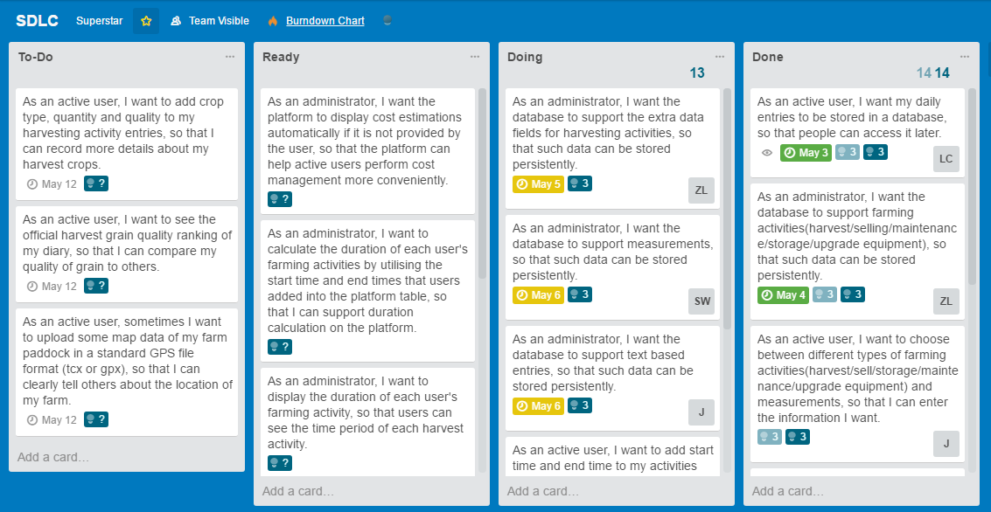

Figure : The SDLC board of Team Superstars, created on Trello, with the tasks contained in the first Sprint.

Story points were again decided with reference to task priority, complexity and uncertainty (CA Technologies, 2017).

The ‘To-Do’ lane contains tasks which need to be completed in order to develop some desired features for the software. The ‘Ready’ lane contains tasks which are ready to be allocated to members. The ‘Doing’ lane contains tasks which are currently being undertaken by a member who has allocated themselves as a resource to the task. Tasks in the ‘Done’ lane are those that have been considered completed and have been reviewed by the team.

## 5.3 SDLC Team Velocity

The Sprint duration of the team was calculated by using a Burndown Chart. This was created by using the ‘expected’ story points on the cards, the result of which is as shown in Figure 5.

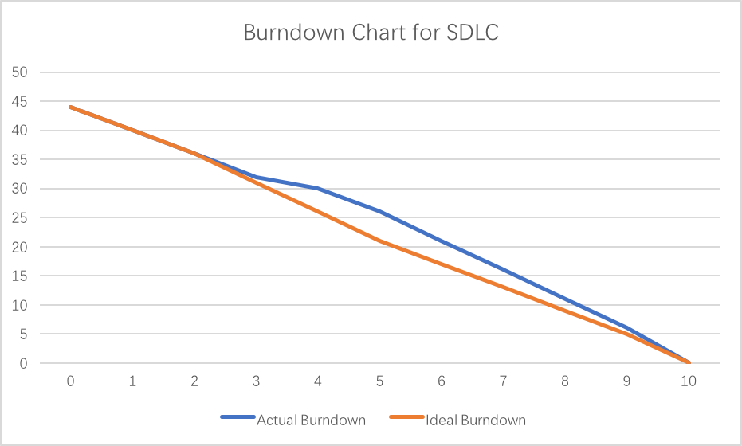Figure : Burndown Chart of Team Superstars’ SDLC Sprint

The Team Velocity in a single Sprint cycle can be calculated by adding up the number of Story Points the team can complete in a short iteration.

The Velocity of Team Superstars were found as follows:

Week 1: 18 story points/week

Week 2: 21 story points/week

## 5.4 Scope Creep

Burnup Charts track both completed work and total required work using two separate lines. It requires information about both the expected and actual story points of the tasks to be completed. Hence it can provide information about scope creep (Clarios Technology, 2016).

Scope creep occurs when work is added to or removed from a project, due to factors such as client requirements changes or project deadline limitations. An increase in the expected work line indicates that work has been added to the project.

Figure 6 shows an image of the Burnup Chart for Team Superstars’ SDLC Sprint.

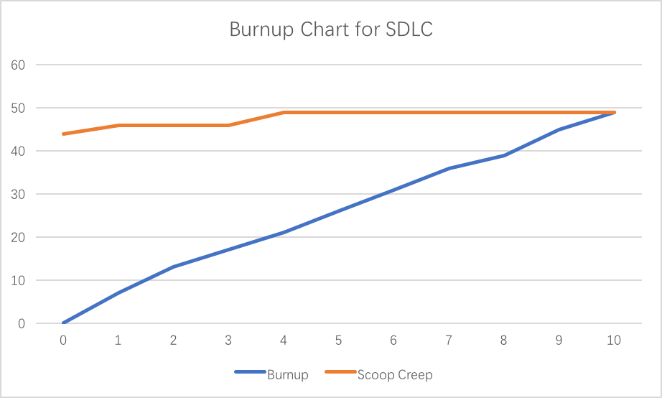

Figure : Burnup Chart of Team Superstars’ SDLC Sprint

# Summary

A new farming social media platform was developed by Team Superstars through employing the Agile Scrum method. The development of the software was performed through the ‘envision’, ‘speculate’, ‘explore’, ‘adapt’ and ‘close’ phases. The project was managed and monitored through use of short PM and SDLC Sprints which had durations of two weeks each. These short timeframes ensured that problems were quickly discovered and progress can be constantly tracked.

In assigning the expected story points of each task in the Sprints, a Burndown Chart can be created to give an idea of the Team velocity. Having implemented a sprint, a Burnup Chart can be produced to keep track of scope creep, which would further help in tracking the progress of the project.

# References

Azarian, I. (2013, July 30). *Key Phases of Software Development Projects*. Retrieved from Segue Technologies: http://www.seguetech.com/key-phases-software-development/

CA Technologies. (2017). *Sizing and Estimates Overview*. Retrieved from CA Technologies: https://help.rallydev.com/sizing-and-estimates-overview

Chandana. (2012). *Agile Certification Training: Agile Project Management Framework*. Retrieved from Simpli Learn: https://www.simplilearn.com/apm-framework-article

Clarios Technology. (2016). *Burn Up Vs Burn Down Chart*. Retrieved from Clarios Technology: http://www.clariostechnology.com/productivity/blog/burnupvsburndownchart

Cohn, M. (2016). *What are Story Points*. Retrieved from Mountain Goat Software: https://www.mountaingoatsoftware.com/blog/what-are-story-points

Colophon. (2017). *The Six Phases of Project Management*. Retrieved from Project Management Training: https://www.projectmanagement-training.net/category/six-phases/

Haughton, B. (2011). *Agile Scrum Sprint Length: What's Right for You*. Retrieved from Methods and Tools: http://www.methodsandtools.com/archive/scrumspringlength.phpM

Palmetto Document Systems. (2017). *Project Initiation Phase*. Retrieved from Project 123: http://www.method123.com/project-initiation-phase.php

Project Performance Australia. (2017). *Types of Requirements*. Retrieved from Project Performance International: http://www.ppi-int.com/systems-engineering/types-of-requirements.php

Waters, K. (2007, September 28). *How to Estimate Your Product Backlog*. Retrieved from All About Agile: http://www.allaboutagile.com/how-to-implement-scrum-in-10-easy-steps-step-2-how-to-estimate-your-product-backlog/